Mon Night Marketing SPR 2010
By:
Aaron Greenfield
Michael Hirsch
Leah Johnson
Lauren Maute
Stephen Weisgerber
Under Armour Team 1

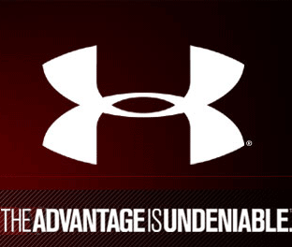
Table of Contents
Chapter 1: Business Description pg 3
Situation Analysis pg 4
SWOT Analysis pg 5
Chapter 2: Brand Equity Inventory pg 6
Brand Heritage pg 7
Brand Representatives pg 8
Brand Identifiers pg 8
Brand Domain pg 9
Brand Essence pg 9
Key Strategy Questions pg 10
Chapter 3: Brand Personality Statement pg 11
Chapter 4: Competitive Map pg 12
Chapter 5: Target Consumer Description + Insight pg 13
Chapter 6: Positioning Statement pg 13
Chapter 7: Price Description pg 14
Chapter 8: Strategic Message Map pg 16
Chapter 9: Creative Work Plan pg 17
Business Description:
Pictures:
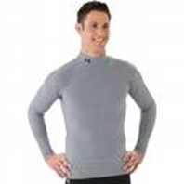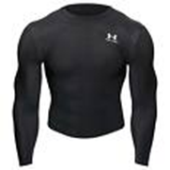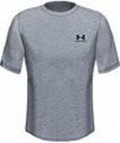

Under Armour is in the business category of supplying athletes of all ages and races with superior athletic clothing. Under Armour has been in this field since 1996 and is now one of the most respected athletic apparel providing companies in the United States and the world. In the world of marketing, Under Armour competes with corporations such as Nike, Adidas, Champion, and Reebok to provide the most comfortable clothing to wear during sports. The advantage that Under Armour holds is the reputation of its brand. The material is a synthetic material made for moisture management and is easily the leader in the market for performance apparel. Under Armour goes after the most hardcore of athletes, boasting a clothing line that assists in sweat collection prevention and maintains the same weight throughout the workout, practice, or game. This is one of Under Armour’s best features and is what keeps customers returning.
Benefits of Under Armour clothing include sweat management, comfort, and flexibility while playing the respective game. With Heat gear and Cold gear performance lines, athletes feel constant body temperature no matter the weather conditions. When an athlete is working as hard as they can, Under Armour is as well; reducing the amount of sweat that trickles down the body, and helping the athlete compete as best they can. As far as social benefits go, Under Armour does have a nice appeal, and accentuates the features of the human body because most clothing items are form fitting.

Under Armour Situation Analysis:
Founded by Kevin Plank a former University of Maryland football player in 1996, Under Armour is a high performance apparel company providing sporting and leisure wear for a variety of different activities. Under Armour is a young company in comparison to some of their top competitors Such as Adidas, Nike, and Reebok. Under Armour faces challenges as a young company in a dominant industry controlled by large well established sporting apparel companies that have been involved with this market for decades. As well as to improve their brand as a house hold name and prove to their consumers that they can produce equal or better quality good as their competitors can.
Under Armour provides Superior Athletic Apparel for Athletes in their three main lines of Apparel, Heat, Cold and All Season Gear. Under Armour appeals to all types of athletes around the world, catering to a wide variety of different sporting apparel goods. Consumers that use Under Armour purchase Under Armour products for their durability and superior performance. While being used for a vast variety of different activates Under Armour’s products stand up to athlete’s expectations of reliability and efficiency. By providing the highest quality and longest lasting products Under Armour has been able to target athletes and encourage them that their product is a superior choice over the competitor.
Most Consumers make choices on what is the best product for them through information they gather on the product and how they feel about the product or their connection to the brand. When you use Under Armour gear you feel more comfortable which builds your emotional connection to the product, while encouraging you to purchase Under Armour products in the future due to their comfort and dependability. This helps consumers make choices on what products to buy in the future, knowing that Under Armour is dependable will bring consumers back for similar purchases in the future.
As a young company Under Armour has the ability to attract to a new generation of athletes. While convincing them that Under Armour is the superior quality brand, and prove that in the future they should continue to purchase their product over the competitors. Creating repeat customers and building a stable base of heavy using consumers that use and purchase multiple Under Armour products. In summary Under Armour is a young up and coming company with high performance products geared towards a new generation of athletes and sports around the world, with high expectations for success.

SWOT Analysis:
Strengths:  Unique brand  Relates to a certain group of athletes that no other brand focuses on. | Weaknesses:  Hard time marketing to women  Has a small consumer target market  Niche Brand
Opportunities:  Branching into a women’s market  Branching into every-day men’s market  Creating more and more innovative clothing  Brand evolution | Threats:  Another athletic company coming in and taking them out by focusing on hard core athletics.  Consumer trend away from “ruthless” sports

Brand Equity Inventory:
These next few pages go into a description of the brand’s past, present, and future. There are also pictures of what types of styles the brand offers to its consumers.

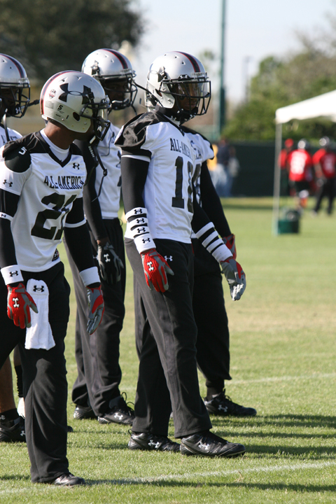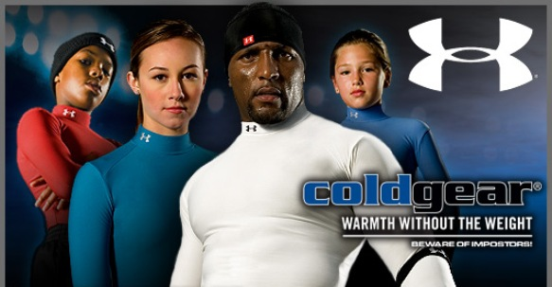

Brand Heritage:

Kevin Plank is the founder, CEO, and director of Under Armour. He was a football player for the University of Maryland and he got tired of always having to change out of his sweaty t-shirts under his jersey. So in 1996 he founded Under Armour so other athletes could have a shirt that would stay dry.
“It started with a simple plan to make a superior T-shirt. A shirt that provided compression and wicked perspiration off your skin rather than absorb it. A shirt that worked with your body to regulate temperature and enhance performance.” Under Armour created gear to wear when playing sports in the heat or in the cold and they have designed the material to help keep the athlete as cool or warm as they need to be while also keeping them comfortable.
So their start was to make t-shirts designed to help people participating in all types of sports, they have since branched out in the past 14 years and have created shirts, shorts, underwear, shoes, accessories for everything, and the ability to pick a sport and go online and create your own outfit. They have emerged as one of the leading brands in athletic apparel with the main emphasis in clothing.

Brand Representatives:
If you see an athlete in a tight long-sleeved dry shirt it makes you think of Under Armour because that is their biggest seller, and on a side note that is normally the brand the person is wearing. Under Armour has the best dry-fit technology and most athletes know that. You also see a lot of runners and skiers wearing long-sleeved shirts because it helps keep their body temperature warm even when the outdoor air is freezing cold. Runners down here in Ft.Myers even use Under Armour because the summer heat can get pretty hot and the shirts are made to help absorb sweat and stop you from passing out due to heat exhaustion. Even though the shirts are what Under Armour is mainly known for they have branched out and created more and more items. All you have to do is look for their symbol because they have that representing all their items. Other brands make dry-fit now too, but Under Armour was the first and to some people that alone is why they will choose Under Armour.

Brand Identifiers:
The symbol that most people identify with Under Armour is the. They also will use the letter “U” sometimes but mostly they stick with the symbol. They do a really good job of making this symbol noticeable on their athletic wear. Their goal is that when people see that symbol their minds automatically go to the thought of an intense, extreme brand.
The Under Armour symbol has become very recognizable. Under Armour was made by a college football athlete for other athletes of all ages. He has put the symbol on every article of clothing. Since they keep it simple and just use the one symbol they are able to market their product better because people know their symbol. Some companies change up their symbol or have multiple symbols, but Under Armour only has one, which possibly is what helps their brand become more recognized. Their main representatives are their tops. The tops have been around the longest and that is what most people even today will buy.

Brand Domain:
The widest market that Under Armour can compete in would be the entire sports market. As of now, the sports industry has been the largest focus for the corporation, traversing such clothing arenas such as football, basketball, baseball, soccer, hockey, and golf. Golf is the latest venture by Under Armour, and there is now golf apparel in every Dick’s, Sports Authority, and Under Armour outlet around the country. The company also makes running shoes and cleats for everyday use by athletes which have been a huge success for the company.
Under Armour should remain in the sports industry, as that is where the brand has seen their success. The company markets in areas such as college and professional football, the MLB, NHL, NBA, and even to football and soccer leagues in Europe. Twenty four NFL teams have already signed multimillion dollar contracts with Under Armour and business is still booming. The company mostly markets to male athletes, but is beginning to broaden their horizons to the female crowd with some success. In 2002, Under Armour became the official supplier for Major League Soccer, and the U.S. Ski Team, and was named Best Apparel Supplier of the Year by Sporting Goods Magazine after only being in business for 8 years.

Brand Essence:
For the hard-core athlete

Key Strategy Questions:
Which of the characteristics above must be retained?
The Brand Essence must be retained. If we lose our brand essence then we lose everything our brand stands for. We are already in the hardcore athletic market and to not keep our essence hardcore could cost us a lot of business. The brand name and image of how well their clothing holds up is a huge part of making Under Armour what it is.
Which should be evolved?
Brand Domain should be evolved to an extent. If we can expand the brand to include the “average Joe” workout guy as well as women (eventually) then we will increase our market share and make our brand even more popular and used. If we can further evolve our brand domain more people may become interested in wearing Under Armour.
Are there negatives we should strive to eliminate?
The biggest negative is that we only reach the hardcore athlete and we need to branch into other types of athletes so we can make more money. The bigger our group of customers is the more profits we can get.

Brand Personality:

As a Person 
If the Brand was a person it would be Vin Diesel. He is a tough, intense guy; just like Under Armour. This brand is not afraid of competition, in fact it makes them stronger. Under Armour promotes that tough intense image. They exist to make you, the customer, stronger. Under Armour stands for intense, hard work and if this brand was a person there wouldn’t be anyone better than Vin Diesel. Under Armour’s whole mission is “TO MAKE ALL ATHLETES BETTER THROUGH PASSION, SCIENCE AND THE RELENTLESS PURSUIT OF INNOVATION” (http://www.uabiz.com/company/mission.cfm).
He is striving to make athletes better by the clothes they wear. Under Armour wants to help athletes be as comfortable as possible while they play and compete but they also want them to be able to look good as well. Under Armour is studious, carful of its competitors but humble and vigilant always learning from their encounters and growing with every opportunity. Under Armour is aggressive and ambitious company, constantly pushing the envelope of sporting apparel and turning up the intensity for its competitors. Striving to have the edge over their competitors and prove to their consumers that they can not only compete with the best but, be considered as one of the elite.

As a Friend
The Under Armour brand is your friend because he makes clothing that is practical and useful. An important character quality in a friendship is trust, honesty, and dependability. You want a friend who is a tough, rough person and will defend you at all costs. Under Armour would be that find of friend. When you walk into an Under Armour store you know you are not only getting a great quality of clothing but you are also getting a product that you know will help you stay more comfortable during your cardio activity. Under Armour is one of those brands that will never leave you hanging which is a great quality in a friend.
If the Brand spoke to you
If Under Armour could speak he would say
“Let me help you” or
“I want you to become better at what you do” or
“Hard work and dedication will help you succeed”.
I got these responses from what I have learned about the company as well as the founder of Under Armour. It is a brand that exists to help the customer. If they weren’t successful in doing that then their company wouldn’t be growing and gaining business. The whole message the brand would preach to you is to “trust me”. They have engineered ways to help performance run at a more optimal level and their goal is to keep developing and keep helping.

Target Consumer:
Under Armour is targeting the hard core athlete. No matter where you live or what you do for a living they are trying to get your business. A lot of the customers may possibly be people who are not athletes for a living but enjoy hard core activities as hobbies. Their lifestyle is extreme, they enjoy adrenaline rushes and living on the edge.

We have decided to target the guys who share the ambition of the hard-core athlete, but don’t spend as much time in the gym and doing activities. They are the average Joe workout man who is interested in looking good and getting an intense workout. They may not do daredevil stunts, but they still need clothes when they are in the gym. We are going to use the passion that these “average Joe’s” have with the athletic branding we have already built up.

Positioning Statement:
To those athletes of all kinds who don’t believe in losing, Under Armour is the outfitter that helps you push yourself to the extreme in all you do.

Price Description:
- Competition:
1. Nike
2. Adidas
3. Champion
4. North Face
5. Columbia Sportswear

- Chart of the prices

Brand Name | Name of Shirt | Price per Unit | Size
UnderArmour | Heatgear | $49.99 | L
Nike | Nike Pro | $30.00 | L
Adidas | ClimaLite | $30.00 | L
Champion | Double Dry | $25.00 | L
Columbia | Titanium | $35.00 | L
North Face | Vaporwick | $40.00 | L

We believe that UnderArmour should continue its current pricing strategy because the next closest competitor is selling for ten dollars less. UA has a reasonable price for its quality, and should keep its prices where they are. UnderArmour’s brand essence will still be strong enough to sell their heatgear shirts without making any price cuts. The regular competitors, Adidas and Nike have considerably lower prices than Under Armour, but UA is still having a healthy volume of sales.

3.
a. Skimming: Price skimming is not right for Under Armour because it would appear that the value of the heatgear shirts is declining. We want to keep our price stable so our consumers know we stand for quality.
b. Penetration: Price penetration wouldn’t be good for Under Armour because we would have to differentiate each time we raise the price on why the increase is needed. Since the quality is already set there is no need for penetration pricing since Under Armour already has a large share in the market.
c. Status Quo: Under Armour is already making profit at a higher price so there would be no need to copy another companies prices.
d. Value Based: Value Based pricing is perfect for Under Armour because we believe we have a superior shirt. Under Armour is known for their quality and endurance. Even though our price is a little higher people are still willing to pay because they know the value.

4. Under Armour’s value will be determined by the brand name value. Our name is what makes our brand unique and special. We will use the name “Under Armour to our advantage!

CREATIVE WORKPLAN
Purpose of the Advertising
We are trying to expand the current consumer group. We are trying to reach the “average joe” male who wants to work out, but can only do so for a short period of time or doesn’t want to do anything extreme. There are a lot of men and we want to be able to reach men of all shapes and sizes. We have already reached the extreme workout group, but now we would like to reach the average male.
The Advertising is addressed to:
The average male is our target. This is the man who has a family, or runs a business; someone who is too busy to go out and do extreme physical activity but still wants to go to the gym and workout. This man may not feel like he is extreme enough to walk into the gym in Under Armour so we need to reach that man and let him know he can become better by using our product. We are trying to prove to him that our product isn’t just for hardcore athletes and that he should choose us over our competition.
Major Selling Idea
The uniqueness about our brand is that we are already known as hardcore. Using that as a base we can show the average Joe how our company can partner with him and help him become the fit, in shape man he wants to be. Men workout to feel better and we can use our hardcore edge to help them believe by using our product they will look better.
Media to be used:
TV commercials during the 6pm news is one of the most effective ways to get to the average Joe. Most of the time men are more likely to come home and turn on the news to see what has happened that day. Another good time might be during reality shows that are already about exercise (i.e., Amazing Race, Survivor, Biggest Loser,ect). Normally when people watch these shows they get inspired to get out and exercise but don’t know where to start. If we can make Under Armour appealing and easy then we might attract new customers.
Therefore what kind of ads will you create?
The TV ads in the shows listed above should run about 30-50 seconds. That is enough time to get our point across without looking like an infomercial. Putting our add in Men’s Health (full page) would also be a good idea, because a lot of average Joe’s read magazines wanting to become healthier but may not actually be doing what they are reading. If we put our add in and express the new market we are targeting, that might help bring in new customers. We could make our website easier to locate the new division of “average Joe” wear instead of trying to advertise on other sites just to be re-directed to our web page. Anything to make it easier for the customer will help our company out the most. If we advertise on the radio our best outlet would be talk radio or possibly even news radio stations. Most older men that are trying to work out (or moderately workout) would listen to those kinds of stations.

Works Cited
http://www.slideshare.net/fagansp/Under-Armour-040608
http://ezinearticles.com/?The-History-of-Under-Armour---A-Mastermind-for-Performance-Apparel&id=127493
http://www.uabiz.com/company/about.cfm
http://investor.underarmour.com/investors.cfm
www. uabiz.com/company/about.cfm
http://www.gobros.com/under-armour/under-armour-history.php
(http://www.uabiz.com/company/about.cfm)

